Zebrafish Engineering Module (Grades 3-5)
Aligned Minnesota State Science Standards
3rd Grade - 3.1.1 Students will be able to develop, revise, and use models to represent their understanding of phenomena or systems as they develop questions, predictions and/or explanations and communicate ideas to others.
4th Grade - 3.2.2 Students will be able to use their understanding of scientific principles and the engineering design process to design solutions that meet established criteria and constraints.
5th Grade - 4.1.2 Students will be able to argue from evidence to justify the best solution to a problem or to compare and evaluate competing designs, ideas, or methods.
Essential Question
How does the significance of zebrafish assist engineering prosthetics?
Day 1
Essential Question - How does the significance of zebrafish assist engineering prosthetics?
Content Objective - Students will identify characteristics between humans and zebrafish.
Language Objective - Students will make connections between humans and zebrafish through written and drawn observations.
Academic Language - identify, observe, compare and contrast, zebrafish, engineer, prosthetic
Name: Pre-Assessment | Y/N
- What fish is relatable to humans?
- What are the steps involved with the Engineering Design Process?
- I____________
- E_______ and ________
- P________ It
- C________ It
- T________ It
- I_________It

- What is a prosthetic?
Introduce Zebrafish – Direct Instruction, Pre-Assessment
Good morning! Before we get started, I will hand out a quick pre-test for you to complete. This will not be graded, but I would like to see what you know about engineering before we get started.
(After students complete the pre-assessment) Did you know there is a species of fish that is relatable to humans? This fish is a vertebrate just like us! If you’re capable, reach your hand behind your back and feel your spine – that is your backbone. This is what classifies us as vertebrates! The fish we’re about to observe has a backbone just like you and me.
The unique fish we’re going to learn about is called a zebrafish! Zebrafish also have a similar genetic structure to humans. They share 70 per cent of genes with us. Not only are zebrafish vertebrates, but they have the same major organs and tissues as we do. Their muscle, blood, kidneys, and eyes share many features with human systems!
Before we observe, what do you think a zebrafish looks like? Do you know anything about zebrafish?
Observe Zebrafish – Guided Practice
I am going to use this Circle Map (front page of Engineer Design Process packet) to help me stay organized while I record as many zebrafish features as I can. I’m going to focus on how it moves and behaves in the tank. Once I am finished observing, I want you to grab an Engineer Design Process packet that is on the front table and record your observations. Once you have completed your observation, go back to your seats, and record your findings.
Teacher will think aloud and make comments such as:
- “I’m looking at how it moves… I’m going to write down how it uses its tail and fins.”
- “I see the fish keeps opening and closing its mouth.”
- “Wow! I better record what details I see on the fish. Maybe it’s helpful, maybe not but I want to be detailed.”
- “I wonder what happens if a fish was hurt? Could I fix or help it?”
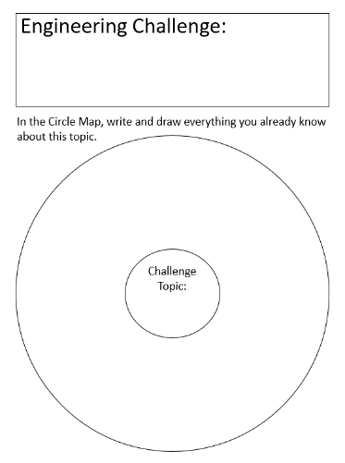
Post-Observation - Collaborative Learning
Flip your paper over and answer the following questions with your tablemate. Keep in mind, your answers do not need to be accurate, but it’s important to have a well-thought answer. Once you have finished, put it away in your science folder. You will need this for tomorrow so be sure not to lose it!
- What happens when the fish opens its mouth?
- Why do you think the zebrafish got its name?
- How do fins help the fish live underwater?
- Gill help fish breathe. What helps humans breathe? Similarities? Differences?
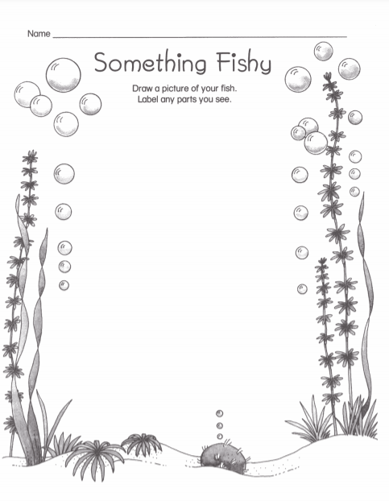
Drawing Observation – Independent Work
On your own, I would like you to draw a detailed picture of the zebrafish from memory. From the front table, grab a “Something Fishy” worksheet. Please include as many details as you can and label the parts of your drawing such as gills, fins, mouth, eyes, and any other information that is valuable. You may want to include questions you’re asking yourself about these incredible fish as well.
Direct Instruction
When you have finished your drawing, please put it in your science folder for tomorrow because we are going to learn about another fish who has a very big problem!
Collaborative Learning
Does anyone know what the term prosthetic means? Turn and talk to your table mate. Be ready to share your definition with the class.
The term prosthetic means “an artificial body part”. Some of you may have seen a prosthetic leg or arm before.
Do you think prosthetics are important for humans to have access to? Why?
Once again, turn and talk with your partner. We will share as a group in 1 minute.
Introduce the Problem – Guided Practice
Think about this…what would happen if a fish’s tail were injured or broken? Would there be a way to save the fish? Scientists and engineers have been challenged with this situation before! I will pass out an article called Winter’s Prosthetic Tail. We will read this passage together – I will read aloud, and you follow along with me.
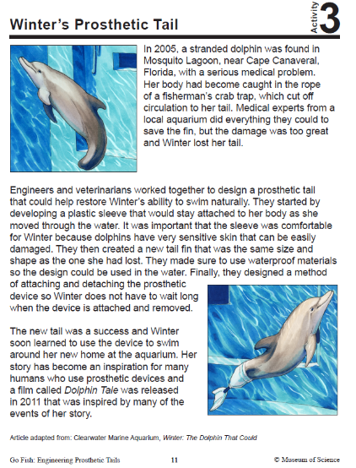
Class Discussion/Introduction to Engineer Design Process – Guided Practice
Talk about it:
- What did engineers have to keep in mind when designing Winter’s tail?
- What challenges did they have?
- How did they solve these challenges?
Imagine It!:
Introduce the Engineering Design Process
This is a step-by-step process that real-life engineers use to find a solution to a problem.
- Identify the Problem
- Explore & Imagine
- Plan It
- Create It
- Test It
- Improve It
Closure – Direct Instruction
Tomorrow, we will go more in-depth with the Engineering Design Process and apply it to what we have learned from this story. Be thinking of how the engineers and veterinarians collaborated to help Winter.
On your way out, tell me one thing you learned today!
Day 2
Essential Question - How does the significance of zebrafish assist engineering prosthetics?
Content Objective - Students will collaborate in groups to design a prosthetic tail by using the Engineering Design Process.
Language Objective - Students will incorporate the Engineering Design Process to brainstorm, assemble, and produce a prosthetic tail for an injured fish. Students will collaborate in small groups to foster creativity and enhance communication skills.
Academic Language – brainstorm, identify, investigate, observe, compare, contrast, zebrafish, prosthetic, engineer(ing), Engineering Design Process
Review Day 1 – Direct Instruction, Assess Prior Knowledge
Think back to yesterday… Who will summarize and review what we were learning about yesterday?
What was the Engineering Design Process?
What was the problem with Winter?
For the next couple days, you will observe the zebrafish and in groups, you will be challenged with creating a prosthetic tail.
Observe the Zebrafish (2nd Observation) – Independent Work
Pull out your Engineering Design Process packet from your science folder. You will record your observation of zebrafish on the same page as you recorded yesterday’s findings. Please take note any new observations. You may want to refer to your original observation before observing today. Remember, it is important to be detailed and thorough with these observations! When you are finished, you can begin brainstorming how you would create a prosthetic if you had to.
Students will record their observations individually.
Review Winter’s Prosthetic – Guided Practice
I know we covered A LOT of information, and it is hard to take it all in, so let’s talk about it together and use Winter’s Prosthetic Tail passage as an example.
- When we identify a problem, what does that mean? To me, it means something “isn’t right” or it is not how it should be. This could mean it is an issue to someone or something!
- In the passage, what was the problem? The dolphin’s injury caused her to lose her tail!
- How did the engineers and veterinarians explore and imagine? They designed a prosthetic tail to help Winter swim again. They had to explore and imagine how they could help the dolphin before even attempting to construct the tail!
- This leads us to planning. The collaboration between the engineers and vets helped develop a plan of action to solve Winter’s problem.
- Next, the team created the comfortable sleeve, created a new tail fin, and designed a method of attaching and detaching the prosthetic tail!
- Once they put the tail on Winter and she could successfully swim, this means the team tested the tail on Winter and it was effective.
Here’s a question for you to think about… Do you believe the team of engineers and veterinarians came up with one idea, one plan, one creation, and everything worked out?
I’m looking for 3 students to share their opinion.
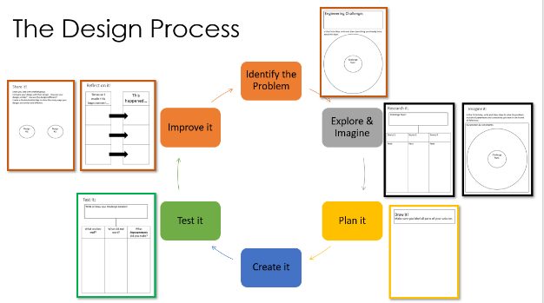
Let’s review our packets together. Each page is labeled with a title. This will be important to focus on as we want to stay as organized as possible!
On the first page, I notice it says, “Engineering Challenge”.
Remember, our challenge for the next few days is: To engineer a prosthetic tail for a model zebrafish that has an injured tail.
Let’s write that down in the appropriate box and move on.
The next step in the Engineer Design Process is to explore and imagine. When I hear the term explore, I instantly thought of how we have been exploring our zebrafish! Now, we need to imagine what could we do if a zebrafish had an injured tail!
I have created a model zebrafish made from plastic bottles. I will place it in a tub of water to demonstrate how it moves.

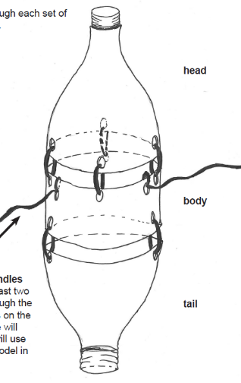
Demonstration/Discussion – Collaborative Learning
In groups of four, discuss those questions. One person from each group will share out.
Discussion:
- How is this model similar to a real zebrafish? How is it different?
- Why can we not use real fish for our design challenge?
- What are the limitations of using a model fish?
- What are the benefits of using a model of a fish?
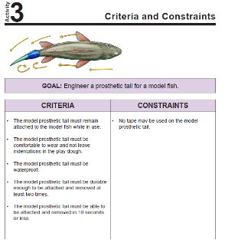
Criteria and Constraints – Direct Instruction
List of Approved Materials
Felt | Foam sheets
Coffee stirrers | Craft sticks
Paper clips | Pipe cleaners
Rubberbands | **Play-doh (adhesive)
Of course, like the team who designed Winter’s tail, there are a list of approved materials that will work for this project. The items you can use:

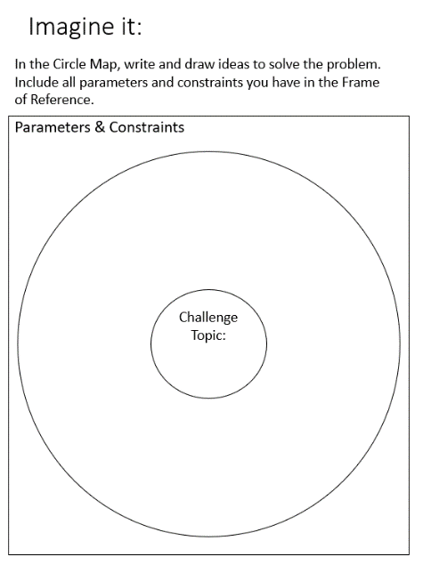

Imagine It – Independent Work
Use the Circle Map on Imagine It in your packet to start brainstorming ideas on how to solve this problem. Think about the list of materials you are allowed to use. How can you put them together to work?

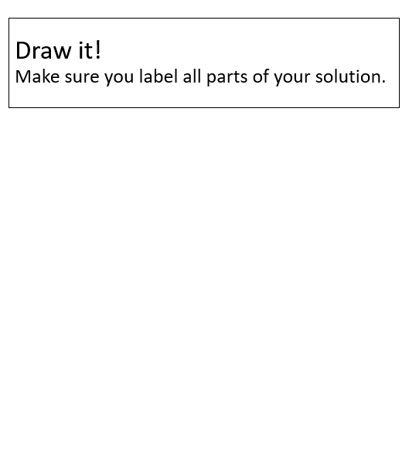
Draw It – Collaborative Learning
Next, you will be placed into groups of 4 (depending on class size) and you will draw up your ideas of the prosthetic tail for the model zebrafish. Please be aware of what collaborating means… this means everyone must put in work to help make the best prosthetic you can. Think of your group as the team of engineers and veterinarians who helped create Winter’s tail!
The teacher will roam throughout the room and view student work and assist any students’ struggling with coming up with a concept. The teacher may make suggestions such as:
“What part of a zebrafish’s tail is important?”
“Have you looked back at your observations? What were key details you included?”

Day 3
Essential Question - How does the significance of zebrafish assist engineering prosthetics?
Content Objective – In groups, students will collaborate to assemble a prosthetic tail while using the Engineering Design Process as a guideline.
Language Objective - Students will utilize their model of a prosthetic tail for an injured fish to test their design and make necessary updates. Students will collaborate in small groups to foster creativity and enhance communication skills.
Academic Language – brainstorm, discuss, identify, investigate, hypothesis, observe, compare, contrast, zebrafish, prosthetic, engineer(ing), Engineering Design Process, reflect
Review Day 2 – Direct Instruction
Let’s think back to the information we learned yesterday. We read about Winter’s prosthetic tail, discussed what we will be creating in groups, and brainstormed a few ideas of how you could create a prosthetic tail for a zebrafish.
Now, we are going to observe our zebrafish, then we will get into our groups, and finally you will build and test your prosthetic tail.

Observe Zebrafish – (3rd Observation) – Independent Work
Grab a pencil, your packet out of your science folder and begin observing the fish. Remember, try to be as detailed as possible and record any new observations! Once you have finished, you may go back to your seats, review your notes, and continue brainstorming your ideas for designing a prosthetic tail.
Review the Problem – Collaborative Learning
Who can tell me what the primary problem you are being challenged with…? If you’re unsure, look back through your packet for answers! (What would happen if a fish’s tail were injured or broken?)
I have broken you into groups of 4. Please get into your groups and begin discussing your models you drew yesterday. Once you all understand your collaborative design, move to the next step of building your prosthetic tail. Keep in mind of the materials you are allowed to use!
To check-in with the students, the teacher will talk with each group and ask how they feel about their project and how everything is going this far.
Build the Prosthetic Tail & Test It - Collaborative Learning
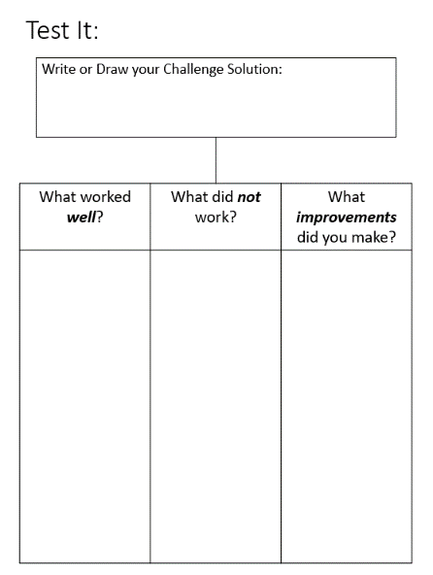
I am so impressed by your designs! You all have done a wonderful job of collaborating and becoming a team of engineers. As you finish up, come up with a hypothesis for how long you think your prosthetic will work. I will time each group and provide it so you can compare the time with your original estimate.
Reflection – Guided Practice
After testing, you will reflect in the packet. Each of you should work independently and write your answers in your packet on the Test It. Since we have not done this before, let’s do it together! In the first category, let’s write what you thought worked well. Next, write what you believe did not work well. Finally, write about what improvements you made for your final design.
(Have students share their ideas for what to write in each category. The teacher will write down one idea under each.)
Closure – Direct Instruction
When you have finished your reflection, put your packet back in your science folder for tomorrow. Tomorrow, we will be finishing any testing that may have not gotten completed today, and then share with the class about your design, your reflections, and hypothesis. Once everyone has discussed, we will look at each other’s designs, and explain your conclusions. Tonight, be thinking of a conclusion for this experiment before you share tomorrow!

Day 4
Essential Question - How does the significance of zebrafish assist engineering prosthetics?
Content Objective - Students will collaborate in groups to present their design of a prosthetic tail.
Language Objective - Students will discuss their designs to foster creativity and enhance communication skills while comparing, contrasting, and examining other groups creations.
Academic Language – brainstorm, discuss, identify, investigate, observe, compare, contrast, zebrafish, prosthetic, engineer(ing), Engineering Design Process, reflect
Review Day 3 – Direct Instruction
Yesterday, you observed zebrafish, built a model, tested your prosthetic tails, and reflected upon your findings.
Today, we will observe the zebrafish for the last time, record any new observations, view your classmates’ designs, and have a discussion.
Observation – (Final Observation) – Independent Work
For the last time, please grab a pencil, your packet out of your science folder and begin observing the fish. Remember, try to be as detailed as possible and record any new observations! Once you have finished, you may go back to your seats and review how you are going to share your group’s design with the class.
Review the Problem – Collaborative Learning
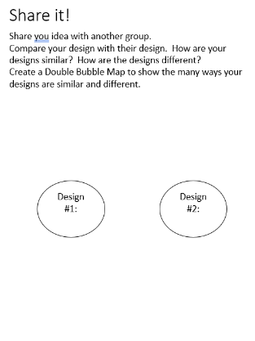
Think back to our challenge… What would happen if a fish’s tail were injured or broken? This will be the primary focus when viewing your classmates’ designs. Please be respectful and keep the positivity alive for your class – you have all worked very hard on your designs. It’s important to stay silent, listen, and observe how others created their prosthetic.
Share It - Have groups share their prosthetic tails.
Conclusion – Guided Practice
We will be using a Double Bubble Map to write/draw similarities and differences between your design and one other groups’ design. Flip through your packet to the Share It page and follow along with me. Let’s write down one way another group’s design was similar to yours. Next, write down how it is different. If you have a grasp on how to do this, add more similarities and differences.
End of Module – Direct Instruction
I am amazed by each and every one of you for the dedication, hard-work, and collaboration you’ve shown. You all are true engineers now! This week you observed zebrafish to assist you with the Engineering Design Process, identified the problem of what would happen if a fish had a broken tail, explored, imagined how you could solve the problem, created a prosthetic, tested it, and made necessary improvements. You have officially mastered the design process and could one day design prosthetics to help others! I hope you had fun with this module – I know I did!
Final Assessment – Independent Work
Name: Post-Assessment | Y/N
- What fish is relatable to humans?
- What are the steps involved with the Engineering Design Process?
- I____________
- E_______ and ________
- P________ It
- C________ It
- T________ It
- I_________It

- What is a prosthetic?
Before leaving, you will complete a final assessment to check for how much you learned throughout this module! You may recognize the questions from the first day!

ACCOMODATIONS FOR THE MODULE
If a student needs accommodations, this module can be differentiated by providing a partner during independent work, allow extra time for completion of work, use a combination of written, verbal, and pictorial instructions with scaffolding, demonstrate procedures, and allow students to practice. A print-out of the module can be provided, as well as sentence starters and drawn observations versus written.
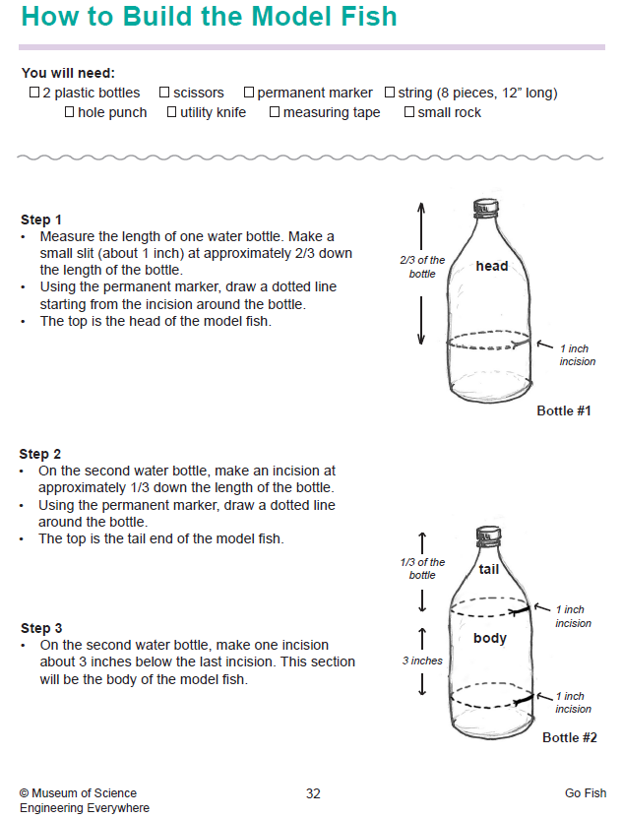
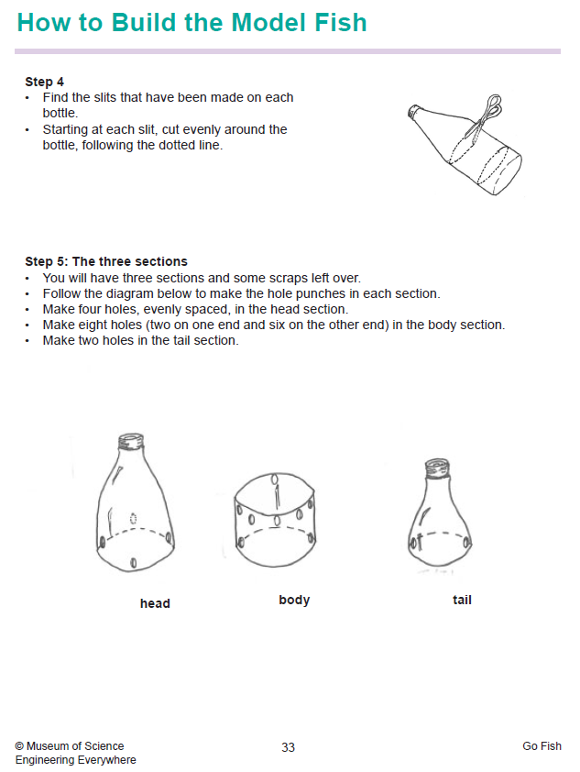
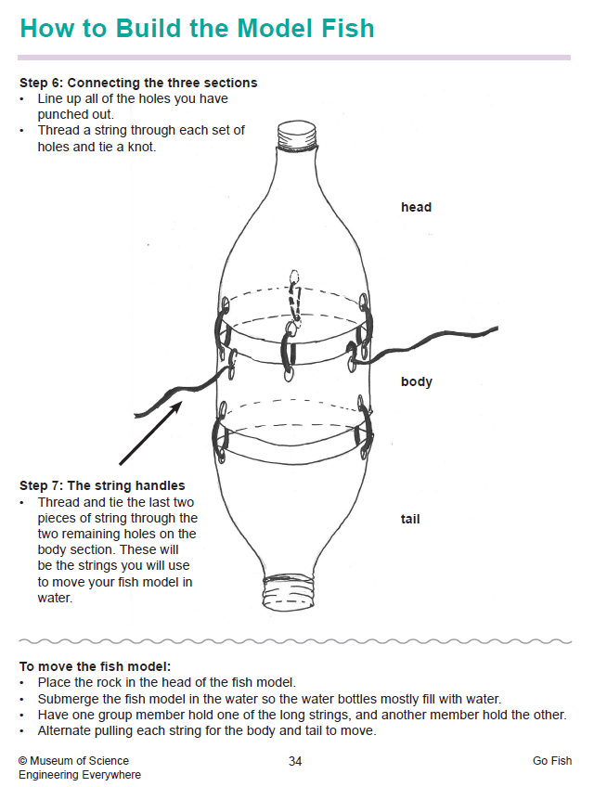

Suggested Materials:
